**Karnatak Law Society’s**

**GOGTE INSTITUTE OF TECHNOLOGY**

**Udyambag, Belagavi – 590 008**

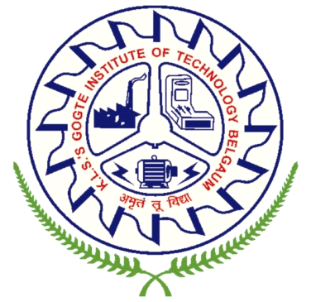

**DEPARTMENT OF ELECTRONICS AND COMMUNICATION ENGINEERING**

**Certificate**

Certified that the project work entitled **“DETECTION OF RICE VARIETIES AND QUALITY ESTIMATION USING IMAGE PROCESSING”** carried by **Mr. Darshan B. Kokare** bearing **USN:2GI11EC025** bonafide students of **Gogte Institute of Technology, Belagavi** in partial fulfilment for the award of degree of **Bachelor of Engineering** in **Electronics and Communication** of the Visvesvaraya Technological University, Belagavi during the year 2014-2015. It is certified that all corrections/suggestions indicated for internal assessment have been incorporated in the Report deposited in the departmental library. The project report has been approved as it satisfies the academic requirements in respect of Project work prescribed for the said Degree.

**Signature of the Guide Signature of the HOD Signature of the Principal**

**Asst. Prof. A.V. Deshmukh Dr. Veena Desai Dr. A. S. Deshpande**

Dept. of E&C Dept. of E&C KLS GIT, BelagaviKLS GIT, Belagavi KLS GIT, Belagavi

**EXTERNAL VIVA**

**Name of the examiners Signature with date**

**1. ______________________ ____________________**

**2. ______________________ ____________________**